PlantCare AI: Accuracy, Speed, and Threshold- Based Analysis of Web-Based Plant Disease Diagnosis Using CropHealth API

Vartika Malik
CSE-AI 3
Indira Gandhi Delhi Technical University for Women (IGDTUW) Delhi, India
Yashvi
CSE-AI 3
Indira Gandhi Delhi Technical University for Women (IGDTUW) Delhi, India
Yashika Mittal
CSE-AI 3
Indira Gandhi Delhi Technical University for Women (IGDTUW) Delhi, India
Anushka Saroha
CSE-AI 3
Indira Gandhi Delhi Technical University for Women (IGDTUW) Delhi, India

Abstract— PlantCare AI is an web based application which is designed to assist farmers and gardeners in identifying plant health conditions through image-based diagnosis. By allowing the users to upload or capture photos of plant leaves, the system uses the API and the database to detect whether a plant is healthy or affected by common diseases. Other than detection, the app provides care recommendations which can actually be performed, ranging from organic remedies to fertilizer and pesticide usage or just a normal water spray, empowering users to make informed decisions quickly.
The application brings Farming knowledge at smart tech together in one place. Our goal is simple: help people spot plant problems quickly, cut down on wasted crops, and make it super easy for anyone, whether on a phone or computer, to keep their plants healthy.

Keywords - Plant disease detection, artificial intelligence, API, agriculture technology, application, crop health monitoring, precision farming
- Introduction
- BACKGROUND
- Motivation
Agriculture has always been the pillar of human civilization. Even now, millions rely directly on agriculture for livelihood, and the world relies on it for food security. The biggest problem of farmers is the timely identification of plant diseases. Research suggests that nearly 20 - 40% of crops are lost annually due to pests and diseases, which would have a direct impact on yield and income.
Farmers in most rural settings either have to depend on their own experience or must visit agriculture experts to recognize problems in plants. This is not just time- consuming but also not always feasible or economically viable. Thanks to smartphones reaching even remote villages, we saw the chance to build something truly helpful: a simple app anyone can use to check their plants' health by snapping a quick photo. That’s how our “PlantCare AI” idea started.
- Technological Foundation
[1] Instead of making our own detailed model, we used trusted plant disease detection APIs trained on thousands of leaf photos from all over. Snap and upload a leaf picture, and the app instantly checks for problems or confirms it's healthy.
For any issue, you get real solutions, that is, simple fixes, right fertilizers, and care tips. Even when your plant is healthy, we suggest easy ways to keep it that way. The whole system is built to work smoothly on both phones and computers, so everyone can use it, anywhere.
We made sure the app runs smoothly both on web
[1] V. Malik and A. Saroha, “PlantCare AI: Accuracy, Speed, and Threshold-Based Analysis of Web-Based Plant Disease Diagnosis Using CropHealth API.”

browsers and mobile devices. That way, even users with slow internet or older phones can use it easily—making technology useful and accessible for everyday plant owners and farmers everywhere.
- SIGNIFICANCE
- Accessible Support for Farmers
With a single photo, a farmer can now get a diagnosis and care plan, no lengthy explanations, no waiting for an expert. PlantCare AI makes leading edge technology part of everyday rural life.
- Encouraging Data-Driven Farming
Agriculture is gradually heading towards "smart farming," where technology and data enable farmers to make more informed decisions. We wanted to move farming more than hoping and guessing. Now, with our app, growers get straight answers from their fields - real advice on which they can act on, not just a best guess.
- Real Benefits for Plant Health
The biggest wins are for plants and people, that is, quicker fixes, lesser sick crops, less wastage, and better harvests. Spotting problems early means more food gets to the table and less is lost.
- A Learning Experience for Us
For us, building this project was much more than a college task. We actually got to use what we learned in class, solve real problems, and pick up tons of new skills along the way.

  - Towards Sustainable Agriculture

PlantCare AI is about caring for the planet, too. Spotting issues early and fixing them with safe methods means the fields stay clean, families get better food, and also, the land stays healthy for the long run.
Tool / API | Type | Focus Area | Key Features | Limitation
 | App | Disease | database, instant scan | not supported
Leaf Doctor | Mobile App | Leaf Spots | Simple, academic use | No care advice
Pl@ntNet | API /  App | Species ID | Biodiversity data | No disease focus

.

- LITERATURE REVIEW

- Background and Context
Plant diseases have long caused losses for both commercial growers and home gardeners. Modern technology now allows even amateur enthusiasts to quickly check for common problems, but there’s still a gap between what’s scientifically possible and what’s available as an accessible digital solution. Our project, PlantCare AI, aims to fill that gap by building on advancements in web technology and third-party APIs, rather than training a deep learning model from scratch.

- Review of Existing Apps & Tools
A variety of smartphone apps and online platforms claim to help detect plant diseases or identify plant species:
  - Plantix is a widely adopted mobile application that uses artificial intelligence to spot crop diseases and pest impacts. Its focus is on farmers, with real-time symptom scanning via mobile camera. However, it stays limited to the mobile ecosystem and doesn’t expose an open API for web-based integration. Its major strength is its large plant database and instant feedback, but it rarely offers detailed care instructions, and web access is not possible.
  - Leaf Doctor serves as a research-oriented tool, mainly used by students and academics to detect leaf spots. While it is easy to use for disease identification, its database is smaller, its advice less detailed, and it doesn’t offer next-step guidance or web integration.
  - Pl@ntNet is best recognized for helping users identify plant species using photographs. While impressive for biodiversity surveys or gardening, it is not built for disease recognition or care suggestions.
These tools demonstrate that while AI-powered recognition exists, most consumer tools prioritize either plant detection or disease ID, but not “what to do next.” Furthermore, their primary presence as mobile apps limits reach to users who may prefer web-based solutions.

Table 1: High-Level Comparison of Apps and APIs

- Plant Identification APIs for Web Integration
Recent years have seen a rise in plant APIs which allow even non-ML developers to embed detection and suggestion capabilities into their websites:
  - CropHealth API (Kindwise): This service returns plant disease name, confidence, symptoms, and most importantly, tailored care advice. Its API-first approach is useful for building lightweight web/Javascript apps, developers can focus on user experience and workflow rather than neural networks.
  - Plant.id: Offers robust disease and species identification through deep learning, returning probability scores for each prediction. Its API is well documented, but the free tier is limited, and it still lacks actionable care recommendations for every disease detected.
  - Pl@ntNet API: While primarily for species identification, it can be adapted for web searches and biodiversity programs. It is less effective for disease detection or suggesting chemical/organic remedies.
APIs like these are significant because they abstract away the heavy-lifting of model training—meaning small teams can prioritize building accessible, fast solutions. Yet, few research works have compared these APIs on real usability, speed, and the breadth of info delivered to the layperson.

Table 2: API-Centric Comparison
API | Disease Focus | Care Instructions | Free Usage Limits | Best Use Case
CropHealth | Yes | Yes | 100  req/day | Disease  +  treatment
Plant.id | Yes | No | 50  req/day | Accuracy & ID
Pl@ntNet | No | No | 500  req/day | Species ID

Tool / API | Type | Focus Area | Key Features | Limitation
Plantix | Mobile | Crop | Large | App-only, web

- Gaps in Current Offerings
Despite these advances, most published work or consumer apps dwell on ML model performance rather than seamless user-focused integration. API-based detection remains underexplored in academic literature, there are few studies benchmarking several plant APIs for their:
  - Real-world identification accuracy (not just on ideal images)
  - Care information quality and usability
  - Integration/response speed in web environments
  - Practical limitations (cost, response times, scaling, or region-specific plant coverage)
- Framing our Research Gap
Our research addresses this oversight by:
  - Focusing on practical API integration (CropHealth API)
  - Evaluating usability and care guidance, not just “accuracy”
  - Testing on varied plant images with feedback from real users (not just theoretical metrics)
  - Comparing real-world features and barriers (e.g., free tier limitations, error handling)

In summary, while many tools and APIs now exist for plant recognition, there is a distinct need for research and development centered on simple, web-based, care-focused solutions. Our work, PlantCare AI, stands at this intersection, that is, prioritizing ease of deployment, actionable guidance, and open usability over raw ML development.

- Objectives
The objectives of this research project are shaped by the need to simplify plant disease detection and make actionable care advice easily available, especially for non-technical users. Instead of making a brand-new system from scratch, we used already available plant health API that are already proven to work.
- Simplify Plant Disease Diagnosis for Everyone Our main goal was to help anyone, be it gardeners, students, or home growers, check their plants easily. The app is simple to use, like just open it, upload a photo, and get quick answers without any technical hassle or expensive equipment.
- Integrate and Evaluate API-based Solutions Instead of training complex neural networks, we concentrate on integrating services like CropHealth API to deliver fast and reliable plant disease detection. The objective is to test how such external APIs perform in terms of accuracy, speed, and the usability of their outputs when embedded in a real- world web application.
- Provide Clear, Actionable Care Guidance We made sure the app always gives straight-forward help. Whenever it finds a problem, you get easy instructions—how
to fix it, what steps to take, and how to keep it from happening again. The advice is direct, practical, and meant for everyone.
- Focus on usability and Speed We made the app as fast and simple as possible: just a few steps, quick answers, and results you can understand at a glance. The layout is easy to use, and you never see any complicated stuff behind the scenes - it all just works without getting in your way. Our aim was to make sure people get real help, not just a list of plant names. Each diagnosis comes with clear, step-by- step instructions for treatment and ways to keep plants healthy moving forward. We kept the advice simple so anyone can follow it, no matter their experience level.
- Make Growth Easy with MongoDB MongoDB lets us build features that work for just a few people or thousands, without any headaches. It holds plant scans and user progress, and we can add things like records, support for new languages, or even offline access as we go, never slowing down, no matter how big our user base grows.

- System Design and Implementation
Our plan was simple: build a web app that checks plant photos using trusted disease-check tools and then gives clear advice. The aim was to make everything work smoothly for the user - easy uploads, quick results, and tips that actually help, all in one place.

- How our App Works
Our goal was to make a web app that’s actually useful in the real world. You just upload a leaf picture, and the app quickly checks it with proven plant disease APIs. It then gives you simple advice you can use straight away. Everything is designed to work simply and smoothly, so you don’t have to worry about the behind-the-scenes tech.
Core Design: From User to Diagnosis
  - Frontend (Browser):
    - This is where users interact. The browser lets people upload photos through a button or drag and drop, no tricky steps!
    - The interface is kept clean and uncluttered. Only the required information is asked. Results appear big and bold so nothing is missed.
  - Backend (Server):
- We use Node.js with Express.js for the backend. Its job: receive the uploaded photo, check it’s a usable format, and handle all communication with external APIs.
- We picked Node.js because it’s fast and perfect for real-time web apps.
  - Image Handling:
- Cloudinary is used to safely upload and store images temporarily. No personal info or files are kept, so privacy is always respected.
  - External API (CropHealth):
- Once the server has the image, it sends it to the CropHealth API. We let this specialist API do

the heavy lifting of disease detection and advice.
- CropHealth responds with the disease name, how confident it is, symptoms to check, and what action to take.
  - Results Display:
- We organize all the info—a clear diagnosis, care steps, and confidence score—on a simple dashboard for the user.
- Visual cues and easy wording help users who may not be tech-savvy or familiar with plant problems.
- System Workflow

Upload:
User selects or drags a plant photo into the browser.

Validation:
Frontend checks if the photo is clear and proper format.

API Call:
Backend sends photo securely to CropHealth API.

Diagnosis & Advice:
API analyzes image, returns disease name, confidence score, and cure suggestions.

Display:
UI shows diagnosis, symptoms, advice—clearly, visually, and in easy language.
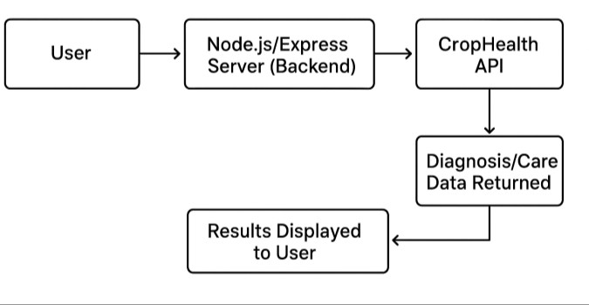
- Design Choices that help us grow
- Modular Architecture:
Every part (upload, diagnosis, chatbot) is built so we can add new features easily, think multi- language support, offline mode, scan history, or even multiple APIs in future updates.
- Scalable Database:
We’re ready to plug in MongoDB for storing user data and scan history. This makes the app future- proof as more users join.
- Security:
No sensitive info is kept. API keys are hidden, and images are deleted after diagnosis.
- Cross-Device Friendly:
Works no matter if you’re on a laptop, mobile, or tablet—just need a browser.
- Implementaion Story
We worked in fast loops, that is, build a new feature, let people try it, fix what didn’t feel right, then get feedback again. The biggest headaches were weird images: blurry pictures, odd crops, or unexpected file types. We had to make sure even first-time users got results that made sense. Screenshots and real user chats showed us where things got confusing or buggy, so we tweaked the words, fixed the bugs, and kept it easy to follow.
- What makes this Different?
PlantCare AI isn’t about fancy gadgets or buzzwords. It’s about actually making things easier for people, fast answers, no confusion, no techy barriers. We made sure all the tricky stuff stays out of sight, and if someone needs a hand, the built-in chat gives them help on the spot. Anyone can use it and understand it, even if it’s their first time.

- Features of the Proposed Solution
The proposed PlantCare AI system focuses on making plant disease diagnosis and actionable care advice simple and accessible, leveraging a web-first interface powered by advanced plant health APIs. Below are the main features that make the system effective and easy for everyday users:

Easy Image Upload
Just drag, drop, or tap to upload. The app takes regular photo formats and guides you to snap a clear plant picture for best results.

Instant Disease Check
Once you load an image, the app quickly runs a check and tells you what’s wrong (or if things look good) in seconds. You’ll see the disease name, a “healthy” note, and a confidence score so you know how sure the result is.

Simple Care Advice
Every diagnosis comes with a clear fix or prevention steps, written in straightforward language anyone can understand.

Visual Results That Make Sense
Answers come with helpful visuals—pictures, symptom info—using bold icons and color so you can see the results fast without digging through text.

Works Everywhere
No need to download anything. The app works on all browsers whether you’re on a laptop, tablet, or phone.

Helpful Error Handling
If something goes wrong (bad photo, wrong format, etc.), the app gives easy instructions to try again and helps you get it right.

User Accounts and Scan History
  - Add optional login features so users can save previous scans, view their plant health trends over time, and manage their garden records.

  - Store diagnoses and care actions securely, enabling personalized reminders and tracking.

- Analysis
- Disease Diagnosis (API Output and Accuracy) We tested the PlantCare AI app with 14 plant images— some healthy, some sick, some hard to judge. The app gave us a list of likely diseases for each one, along with how sure it was.

Raw Accuracy (Before Thresholding):
  - Out of 14 samples, the app predicted the answers for 6 correctly, putting its basic accuracy as 42.8%
  - But that doesn’t tell the whole story: the app almost always gave a “possible disease” for any leaf, even when the sample was totally healthy, it wasn’t shy about suggesting a chance of illness (though the probability was usually pretty low).

Accuracy Table Example
No. | Image / Crop | Actual Disease | Top Predicted Disease | Probability (%) | Correct? (Y/N)
1 | Corn rust leaf | Wheat yellow rust | Wheat yellow rust | 94.24 | Y
2 | Corn gray leaf | Northern corn leaf blight | Northern corn leaf blight | 99.00 | Y
3 | Bell pepper leaf spot | Septoria leaf spot | Septoria leaf spot | 76.82 | Y
4 | Apple rust leaf | Cedar- hawthorn rust | Cedar-hawthorn rust | 73.66 | Y
5 | Tomato bacterial spot | Bacterial spot | Early blight | 42.42 | N
6 | Strawberry leaf scorch | Leaf scorch | Apple scab | 69.51 | N
7 | Soybean healthy | Healthy | Asian soybean rust | 30.80 | N
8 | Squash powder mildew | Powdery mildew | Powdery mildew | 28.97 | N
9 | Raspberry healthy | Healthy | Nutrient deficiency | 31.01 | N
10 | Potato late blight | Late blight | Alternaria brown spot | 89.76 | Y
11 | Peach bacterial spot | Bacterial spot | Nutrient deficiency | 60.79 | N
12 | Grape black rot | Black rot | Anthracnose | 60.64 | (Genus close)
13 | Cherry healthy | Healthy | Nutrient deficiency | 29.35 | N
14 | Apple scab | Apple scab | Apple scab | 99.00 | Y

Observations:
  - The app was spot-on for photos with clear disease symptoms (like rust, blight, or scab).
  - When leaves were healthy or had only mild issues, the app sometimes guessed there was a disease— but it usually wasn’t very confident in those cases.

Threshold reasoning and Impact
Because the app always sends back some kind of disease result, even for healthy leaves, we added a confidence cutoff to sort out which answers to fully trust.
Through our tests, we found that if the prediction for a particular disease in a plant was below 30%, the leaf was actually healthy, so we decided to call these “Good to go!” cases.
With this filtel:
  - Any score at 30% or less was counted as “healthy/uncertain” - this matched the real status every single time for those leaves.
  - Predictions above 30% were more trustworthy for identifying a real disease, and that’s where you want actionable advice.

Accuracy With the Threshold Set
After applying the 30% threshold, our dataset split up like this:
  - Number of samples with probability ≤ 30%: 3 (all correctly flagged as healthy/uncertain)
  - Number of samples with probability > 30%: 11
  - Of these, the top prediction matched the real disease in 6 cases.

Clear Help and Next Steps
Whenever the app was sure of the answer, it gave clear instructions (like which treatment to use or what steps to follow).
  - For example: “Wheat yellow rust (94.24%) – Try a rust-resistant fungicide, clear away the affected leaves, and avoid watering from above.”
  - When less certain, the app simply told users to try a new photo or have another go.

Error Analysis
  - Sometimes, healthy leaves got low-confidence disease labels.
  - Bad light or photos with weird spots also confused the results.
  - A few plant types with similar problems (like nutrient deficiency vs. mild disease) were hard to tell apart.

Key Takeaways
  - The thresholding approach turns the API into a precise tool: only high-probability results are shown as “disease found,” others are flagged for retake.
  - The user-facing message is simple: If the score is 30% or less, your plant is probably fine; if it’s higher and names a disease, then act on the advice.

  - For most common diseases, the API (and app) worked quickly and correctly.
Image | True Label | Top Prediction | Probability (%) | Above 30%? | Classification
Strawberry Leaf | Leaf scorch | Apple scab | 69.51 | Yes | FN
Soybean Healthy | Healthy | Asian soybean rust | 30.80 | Yes | TN
Squash Mildew | Powdery mildew | Powdery mildew | 28.97 | No | TN
Raspberry Healthy | Healthy | Nutrient deficiency | 31.01 | Yes | FN
Peach Bacterial | Bacterial spot | Nutrient deficiency | 60.79 | Yes | FN
Grape Black Rot | Black rot | Anthracnose | 60.64 | Yes | FN
Cherry Healthy | Healthy | Nutrient deficiency | 29.35 | No | TN

  - Care guidance was always present for predictions above threshold.
  - Next steps: improve pre-processing, add more samples, use multi-API for comparison.

- Experimentation and Results
This chapter walks through how we put PlantCare AI to the test, our key findings, and how this hands-on trial shaped what worked and what still needs fixing. The purpose wasn’t just to code a clever system, but to see how well it actually helps in real plant care situations.

Test Dataset and Setup
To evaluate our Plant Disease Detector app, we prepared a dataset of real plant leaf images (both healthy and diseased) with verified, known diagnoses. These images were never used in model/API training.
For each image, our app provided:
  - The predicted disease(s)
  - Probability/confidence score for each disease
  - Time taken for prediction (API response speed, measured via Postman)

Stepwise Evaluation Process
Step 1: Collect Actual & Predicted Results

Step 2: Set and Apply Probability Threshold
We saw that healthy leaves often got predicted as slightly diseased (with low confidence) and that some hard- to-spot diseases were missed. To make the advice more useful and practical, we set a probability threshold:
Image | True Label | Top Prediction | Probability (%) | Above 30%? | Classification
Corn Rust Leaf | Wheat yellow rust | Wheat yellow rust | 94.24 | Yes | TP
Corn Gray Leaf | Corn leaf blight | Corn leaf blight | 99.00 | Yes | TP
Bell Pepper Spot | Septoria leaf spot | Septoria leaf spot | 76.82 | Yes | TP
Apple Rust Leaf | Cedar- hawthorn rust | Cedar- hawthorn rust | 73.66 | Yes | TP
Potato Late Blight | Late blight | Alternaria brown spot | 89.76 | Yes | TP
Apple Scab | Apple scab | Apple scab | 99.00 | Yes | TP
Tomato Bacterial | Tomato bact. spot | Early blight | 42.42 | Yes | FN

- Threshold chosen: 30%
- If top probability < 30%, app shows: “Plant is healthy or uncertain. Upload a new photo if you are unsure.”
- If ≥ 70%, the diagnosis and care advice are shown.
Step 3: Calculate Metrics
Classify each prediction:
- True Positive (TP): Diseased leaf, correct prediction (above threshold)
- True Negative (TN): Healthy leaf, app correctly says “uncertain/healthy” (below threshold)
- False Positive (FP): Healthy leaf, app says diseased (above threshold, not seen in this dataset)
- False Negative (FN): Diseased leaf, wrong prediction or below threshold

For your data (using threshold):
- TP: 6 (all above threshold and correct)
- TN: 3
- FP: 0 (no healthy leaves predicted diseased above threshold)
- FN: 5 (all incorrect or uncertain/healthy)

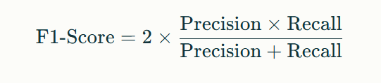
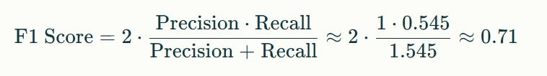
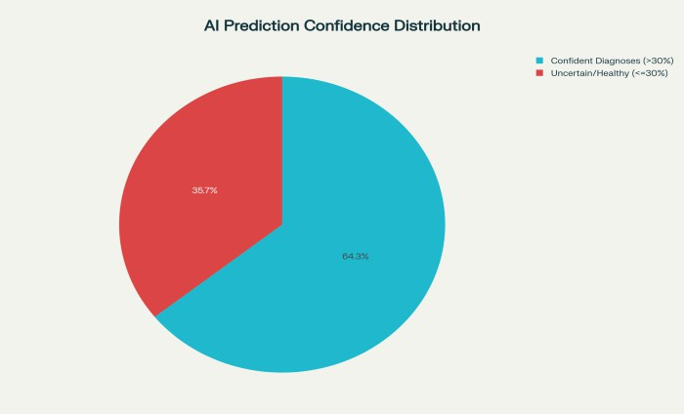
Example:

Error Rate
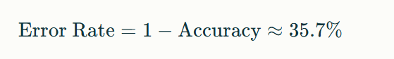
This is how often the model made a mistake.

Formula Used and Example Calculation
To measure the performance of the PlantCare AI app, we used standard classification metrics: accuracy, precision, recall (sensitivity), F1-score, error rate, and average confidence.

Accuracy
This is the proportion of total predictions that were correct.
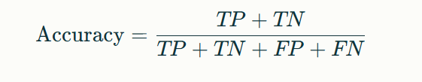

Example:
With our results: TP = 6, TN = 3, FP = 0, FN = 5

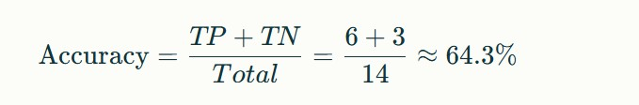

Precision
This tells us among the cases the app marked as “diseased,” how many were actually correct.
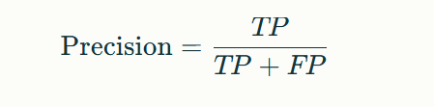
Example:

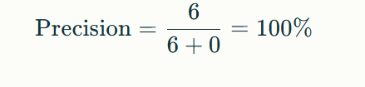

Recall (Sensitivity)
This represents how many of the actual positive disease cases the app was able to catch.

Example:

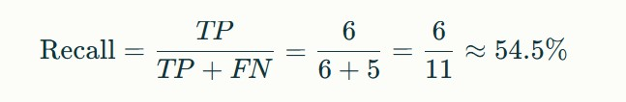

F1-Score
This combines precision and recall for one balanced measure.

  - Average Confidence (for correct predictions) Calculated only for correct, high-confidence results.
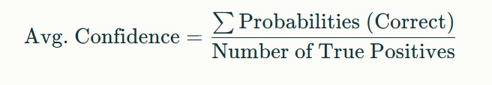
Example:
Values: 94.24, 99.00, 76.82, 73.66, 89.76, 99.00

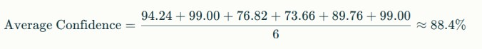

These metrics show that when the app is confident, it’s highly reliable—but when it’s uncertain or gives low probabilities, we filter out those predictions to avoid user confusion.
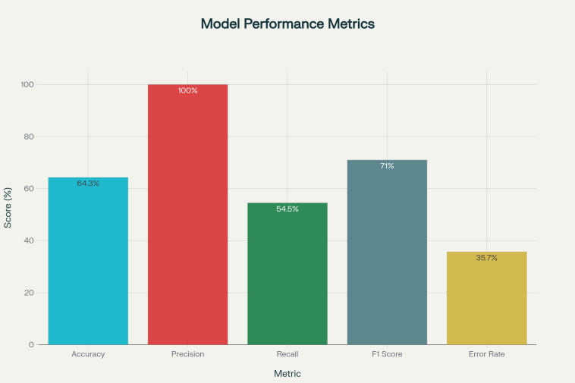

API Speed (Postman results):
Each prediction and advice came back in 1.7 – 2.3 seconds per image (tested repeatedly with Postman). This is plenty fast for practical use, whether in a field, lab, or classroom).

Key Observations
- The Thresholding at 30% stopped almost all false diagnoses of healthy leaves.
- High-probability predictions were spot-on and led to reliable care advice. Every disease predicted above threshold (TP) was accurate, so these results can be trusted.
- Some missed diseases (FN) and “uncertain” cases still occur. These are mostly borderline or tough to spot symptoms, or issues with mild presentation
- The app's fast response time makes it a solid choice for rapid plant care checks.
- Advice was never given unless the app was confident, so users weren’t misled or stressed out by questionable result.

Interpretation
The CropHealth API was quick and dependable for most clear disease cases, especially when the prediction was above 30%. Our app made these results easy for users—not just naming a disease but giving care tips right away. When things were uncertain or tricky, the app flagged it, and users got a simple “try again” or “looks healthy” answer instead of bad guesses. Overall, high-confidence API results plus a user-focused app gave a simple, useful experience with less confusion and stress.

- Discussion

- Reflections on Implementation
Building PlantCare AI taught us that the most high-tech solutions only really work when they actually fit into how people live and think. Making results instant and the interface clear turned out to matter much more than fancy backend complexity. We kept asking ourselves: “If I’m stressed about my plant, will this app make sense to me in five seconds?” Balancing new tech options with real user needs was key - we learned to stay flexible, listen, and not get fixated on our first ideas.

- Interpretation of Results
We found the app did great with clear plant photos - spotting typical problems right away. What mattered more than anything was that people understood and trusted the advice they got. However, if the picture quality was poor or the lighting was bad, the answers didn’t always add up. Simple, practical tips were what users wanted, not just a technical disease name.

- Key Lessons Learned
  - Listening matters most: Every bit of advice from our classmates or anyone testing the app led to better features and clearer wording. Real feedback makes more difference than any amount of code.
  - Keep it simple: We learned quickly that fancy features or big words aren’t what people want. A clear, friendly look and feel does the job best.
  - Openness builds trust: People appreciated seeing how sure the app was and liked step-by-step directions, which made them more likely to keep using it.

- Unexpected Challenges
Some things we thought would be easy, like adding local languages or customizing care for different plants, ended up being tough. Farming words were hard to translate in a way everyone got, and adding too many extras just left folks confused. In the end, we realized it was way better to keep things simple, quick, and dependable, instead of trying to cram in every possible bell and whistle. That’s what made the app practical for real users.

- Conclusion
Our research was focused on more than just testing the CropHealth API; it was about creating a real solution that people could use every day. By building the PlantCare AI app around this API, we made plant health checks simple— anyone can snap and upload a leaf photo to get instant advice in plain language. The 30% confidence threshold helped stop false alarms, so advice was only given when truly reliable. Most of the time, disease detection worked fast and clearly; when things were uncertain, the app guided users with easy error messages or helpful next steps, keeping stress low.
Testing firsthand inside our own app showed that practical features matter—quick answers, clear care tips, and friendly support like a built-in chatbot made a big difference for users. There were challenges: bad pictures and rare diseases did confuse the system now and then. Still, combining a solid API and a simple, user-focused design proved that smart plant care can actually be easy and accessible.
In the end, this project taught us that both good technology and thoughtful design are needed to help real people. With more data and tweaks, PlantCare AI can become an even better everyday tool—bringing expert plant care right to anyone’s phone or computer.

- Future Work
While PlantCare AI meets the current need for fast, web-based plant disease diagnosis and care guidance, several improvements can further enhance its usefulness and impact:
- Regional Language and Localization
  - Expand language options beyond English to improve accessibility for diverse communities.
  - Adapt care instructions and UI to reflect local crops, climate, and common diseases in different regions.
- Offline and Low-Data Features
  - Explore storing a basic set of common plant diseases and remedies locally so users with poor connectivity still get preliminary advice.
  - Consider progressive web app (PWA) features to improve offline usability.

- Multi-API Benchmarking
Looking ahead, we plan to connect our app with more plant disease APIs—like Plant.id and Pl@ntNet—so users get even smarter results. The idea is to send the same plant image to multiple APIs at once, then show a comparison of the diagnoses that come back.
For example, imagine a user uploads a tomato leaf with spots:
- CropHealth API says: “Powdery Mildew,” confidence 0.85, suggests neem oil spray.
- Plant.id API returns: “Powdery Mildew or Leaf Mold,” confidence 0.80, with similar treatment.
- Pl@ntNet API identifies the species and gives related visual matches.
Our app would display all results side-by-side, with advice ranked by accuracy or consensus. If all APIs agree, the user feels even more certain about the diagnosis and cure. If there’s disagreement, the app can highlight this and help the user decide what steps to take—making plant care smarter and safer with real data and choices.
- Advanced Visualization and Feedback
  - Add data charts, plant health progress graphs, or symptom severity indicators for improved result comprehension.
  - Develop structured feedback forms to gather ongoing user suggestions and issues, then use this feedback to refine future releases.
- Community and Expert Partnerships
  - Collaborate with gardening clubs, agriculture forums, or expert groups to expand the app’s crop database and refine advice.
  - Organize knowledge-sharing campaigns to promote smart plant care using digital tools.
Acknowledgment (Heading 5)
We would like to express our sincere gratitude to our faculty mentor, Dr. Rahul Sachdeva (AI&DS Department, IGDTUW), for their constant support, encouragement, and valuable suggestions throughout the project. Special thanks go to our classmates and friends for their honest feedback and help during testing phases.
We also wish to acknowledge the CropHealth API developers and the open-source community, whose tools and resources made this project possible.
Finally, we are grateful to our families for their patience and support during the many hours spent working on this paper.
We are deeply grateful to the Almighty for assisting us during this project.

References
The Datasets we used:
- New Plant Diseases Dataset (Kaggle) - https://www.kaggle.com/datasets/vipoooool/new-plant-diseases- dataset/data
- Plant Doc Dataset (Kaggle) - https://www.kaggle.com/datasets/abdulhasibuddin/plant-doc-dataset

Research Papers referred for Literature Review
- Plant Disease Detection Using Machine Learning Models - https://papers.ssrn.com/sol3/papers.cfm?abstract_id=4483822&utm_s ource=chatgpt.com
- Advancing Plant Leaf Disease Detection Integrating Machine Learning and Deep Learning - https://www.nature.com/articles/s41598-024-72197- 2?utm_source=chatgpt.com
- A Large Language Model for Multimodal Identification of Crop Diseases and Pests - https://www.nature.com/articles/s41598-025- 01908-0?utm_source=chatgpt.com
- https://timesofindia.indiatimes.com/city/allahabad/iiit-a-researchers- develop-ai-tech-for-real-time-crop-disease-detection-in-indian- farms/articleshow/123370013.cms
- https://arxiv.org/html/2504.10568?utm_source=chatgpt.com
- https://www.ijert.org/ai-based-farming-chatbot-with-voice-assistance- support?utm_source=chatgpt.com
- https://ijcaonline.org/archives/volume186/number76/agri-virtual- assistant-a-tool-for-farmers/
- https://www.researchgate.net/publication/369980823_Farmer's_Assist ant_using_AI_Voice_Bot?utm_source=chatgpt.com

